- Copyright for test papers and marking guides remains with West Australian Test Papers.
- The papers may only be reproduced within the purchasing school according to the advertised conditions of sale.
- Test papers must be withdrawn after use and stored securely in the school until Friday 6th December 2013.



PHYSICS

YEAR 11

2B

2013

SOLUTIONS

Section 1: Short Answers

Question 1 (3 marks)
Answer true or false to each of the following.

(a) FALSE

(b) TRUE

(c) FALSE

Question 2 (4 marks)

Step 1 cooling from 20 ºC to 0 ºC
Q = m c ΔT = 0.7 x (4.18 x 10³) x 20 = 58 520 J
Step 2 freezing at 0 º
Q = m L = 0.7 x (3.34 x 10⁵) = 233 800 J
Step 3 freezing from 0 ºC to -4 ºC
Q = m c ΔT = 0.7 x (2.10 x 10³) x 4 = 5880
Total energy removed = 2.98 x10⁵ J

Question 3 (3 marks)

A comprehensive description of any of the safety devices such as a fuse, earth leakage systems (RCDs), earth wires would attract maximum marks.

Question 4 (3 marks)
The molecules of liquid petrol are moving about within the liquid with a particular quantity of kinetic and potential energy. At the surface some molecules escape the liquid and gain energy as they enter the space above the liquid. After some time an equilibrium develops between molecules in the liquid phase escaping, and molecules in the vapour phase re-entering. A vapour pressure, due to the energy of the molecules in the vapour phase, exists above the surface.

Question 5 (4 marks)
(a) work = power x time
= 1.5 x (60 x 60) = 5.4 x 10³ J

(b) As the runner uses more stored energy as the run progresses, they would require blood to be delivered to the muscles at a greater rate. Therefore the heart would need to work at an increased rate so it is likely more than 4 times the work would be done in completing the run.

Question 6 (4 marks)
(a) (b)
Record the measurement 8.5 V Record the measurement 10 V
Record the uncertainty +/- 0.5 V Record the uncertainty +/- 5 V

Question 7 (4 marks)

(a) Work = V q
Work (energy) = (-1.6 x 10⁻¹⁹) x (120 x 10³)
= 1.92 x 10⁻¹⁴ J (2 marks)

(b) 98/100 of (1.92 x 10⁻¹⁴) = 1.8816 x 10⁻¹⁴
E = ½ m v²
1.8816 x 10⁻¹⁴ = ½ x 9.11 x 10⁻³¹ x v²
v² = (1.8816 x 10⁻¹⁴) x 2 / (9.11 x 10⁻³¹)
v = 2.03 x 10⁸ m s⁻¹ (2 marks)

Question 8 (3 marks)
The key concept here is diffusion of gases. When the bottle is opened, particles of the liquid change phase at the interface between the liquid and the air, escape the surface and move beyond the bottle. The particles have kinetic energy and travel through the surrounding air. Because the air is mainly space the particles can travel relatively long distances and can be detected metres away from the source. They are likely to “collide” with each other and molecules in the air.

Question 9 (4 marks)

(a) I = q / t
1.9 = q / (2.5 x 60 x 60)
quantity of charge (q) = 1.9 x (2.5 x 60 x60)
q = 1.71 x 10⁴ C (2 marks)

(b) Work = V I t
Work = 3.0 x 1.9 x (2.5 x 60 x 60)
Work done in moving the charge = 5.1 x 10⁴ J (2 marks)

Question 10 (3 marks)
The current drawn by the heater when operating at its rated power output.
Power = V I
(2.5 x 10³) = 240 x I
I = (2.5 x 10³) / 240
I = 10.4 A
This current (10.4 A) is above the 8.00 A rating of the power board so there is a risk of
damage if a current exceeding the rating is drawn through the power board.

Question 11 (4 marks)
(a)
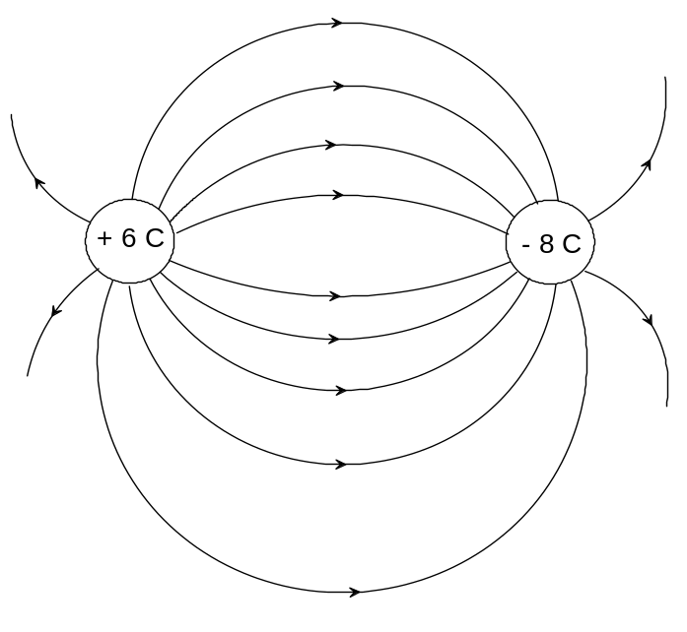 (2 marks)

(b) The charges are likely to move towards each other. (1 mark)

(c) Because of the opposite charges on the particles they will attract each other and so will move closer together. (1 mark)

Question 12 (6 marks)
(a) The small shock is experienced when the door handle has accumulated a charge. The charge is most likely produced by friction between the air and the moving car causing positive and negative charge to accumulate separately over the body of the car. If the person is at a different potential to the car then there may be a discharge between the person and the car, resulting in a small shock.
(2 marks)

(b) As the car body is a good conductor, it is likely that the charge that accumulated on the car was dissipated when the first person touched the handle. As the potential between the second person and the car is now zero, no discharge (small shock) is expected. (2 marks)

(c) Carbon is a good conductor of charge. The carbon in the tyres will tend to conduct any accumulated charge to the road. Hence this reduces the chance of a large build up of charge on the car body. (2 marks)

Question 13 (4 marks)

The bimetallic strip contains two metals that expand at different rates when heated. This causes the strip to bend, with the metal that expands more on the outside of curve. In its inactive position the strip acts as an open switch. When the strip is heated it bends, and closes the circuit and the alarm sounds. (4 marks)

Question 14 (7 marks)

(a) Both the ball and the bat are composed of particles of matter that are vibrating with a particular quantity of energy. When the collision occurs the energy of the particles, at the point of impact in both objects, is altered. In this case the potential and kinetic energy of the particles in the bat is increased. As temperature is dependent upon the average kinetic energy of the particles, there is rise in temperature of the bat wood in the vicinity of the collision. (3 marks)

(b) Q = m c ΔT
18.1 = 0.004 x (2.25 x 10³) x ΔT
ΔT = 18.1 / (0.004 x 2.25 x 10³)
Change in temperature is 2.0 ºC (4 marks)

Question 15 (8 marks)
(a)
(i) Conduction - Blankets are usually made from non conducting materials (Wool,
cotton, synthetics). When the blanket comes in contact with the body there is little
heat transferred by conduction from the body to the blanket. Conversely, little
heat is transferred from the surroundings to the body. (2 marks)

(ii) Convection - Blankets are usually woven material with some air trapped between
the fibres. As convection depends upon the circulation of gas (air), there is little
circulation of air and hence there is negligible loss of body heat through
convection. (2 marks)

(iii) Radiation - The material that blankets are made of, are typically poor radiators of
heat. Lighter coloured fabrics will tend to radiate heat at a slower rate than dark
coloured fabrics. However overall, the loss of heat through blankets radiating heat
is minimal. (2 marks)

(b) The major advantage of doonas over blankets is that they contain large volumes of air which is a very poor conductor of heat. The feathers and fibres can be ‘fluffed up’ to increase the volume of air in the doona envelope hence increasing its insulation properties Any body heat that is transferred to the doona tends to be trapped in the doona thus reducing heat loss by conduction, convection and radiation. (2 marks)

END OF SECTION 1
Section 2: Problem Solving

Marks allotted: 80 marks out of a total of 160 (50%)

This section contains 7 questions.

Question 16 (12 marks)
(a) Resistance in first parallel circuit
1/R == 1/40 + 1/40
R = 20 Ω
This is in series with another 20 W globe so total resistance is 40.0 Ω
Resistance in second parallel circuit
1/R == 1/40 + 1/20
R = 13.3 Ω
Total resistance in parallel circuits combined
1/R == 1/40 + 1/13.3
R = 10.0 Ω (5 marks)

(b) The meter is in series with the resistors therefore it is an ammeter. So to determine the reading the current needs to be calculated.
V = I R
12 = I x 10.0
I = 12 / 10.0 = 1.20 A (2 marks)

(c) The answer is (A)
Supporting calculation:
Current in parallel circuit and hence through globe 1
V = I R
12 = I x 40
I = 12/40 = 0.3 A
Current in parallel circuit 2
V = I x R
12 = I x 13.3
I = 12/13.3 = 0.90
But the current will be in the ratio of 2:1 through the branches. So the current flowing through globe 2 is 0.3 A (3 marks)

(d) P = I² x R
P = 0.3² x 20 = 1.8 W
The power globe 1 is producing is 1.8 W. Its rating is 2.0 W therefore it is operating
BELOW its maximum power output. (2 marks)

Question 17 (13 marks)
(a)
Meter | Is it correctly connected?
Voltmeter 1 (V₁) | yes
Voltmeter 1 (V₂) | yes
Voltmeter 1 (V₃) | yes
Voltmeter 4 (V₄) | no
Voltmeter 5 (V₅) | yes
Ammeter 1 (A₁) | yes
Ammeter 2 (A₂) | yes
(2 marks)
(b)
(i) 90.0 Ω (2 marks)

(ii) V = I R
9 = I 90
I = 0.10 A (2 marks)

(iii) 0.10 A (1 mark)

(iv) 0.10 A (1 mark)

(v)
V = I R
V = 0.1 x 30
V = 3.0 V (2 marks)

(vi) As the battery is a 9 V battery, the reading on the voltmeter would be 9 V.
There is a change in potential. Since the voltmeter is across the terminals of the
battery it will show a potential increase. (1 mark)

(c) This meter is connected incorrectly if any meaningful reading is expected. There is no PD between points in the circuit across which the voltmeter is connected. (2 marks)

Question 18 (12 marks)
(a) Calculate the quantity of electrical energy produced by the circuit.
Q = V I t
Q = 12 x 2.5 x (20 x 60)
Q = 36 000 J which is the energy input (3 marks)

(b) Calculate the quantity of heat energy absorbed by the water.
Q = m x c x ΔT
Q = 0.1 x (4.18 x 10³) x (100 – 21)
Q = 3.30 x 10⁴ J which is the energy output (3marks)

(c) Calculate the efficiency of the system if the aim is to conserve energy between the heating coil and the water.
Efficiency = [(energy output / energy input)] x 100
Efficiency = [33 022) / 36 000] x 100
Efficiency = 92 % (3 marks)

(d) Although heat transfer from the heating coil to the water is efficient, there is some loss of energy by the water to the surroundings. (2 marks)

(e) An insulated vessel that reduces heat transfer from the water to the surroundings would
produce a better result. The time taken for the water to reach the final temperature would
be reduced so the quantity of electrical energy required to heat the water would be
reduced, so increasing the efficiency. (1 mark)

Question 19 (11 marks)
(a) Q = m c ΔT
Q = 150.0 (4.18 x 10³) x 56.0
Q = 3.51 x 10⁷ J (2 marks)

(b) P= Q /t
6.00 x 10³ = (3.51 x 10⁷) / t
time = (3.5112 x 10⁷) / 6.00 x 10³
= 5852 s
= 5852 / 60 minutes
= 97.5 minutes (3 marks)

(c) There are some inefficiencies in the transfer of heat from the heating coil to the water
and further losses from the tank to the surroundings due to imperfect insulation.(1 mark)

(d) Cost = 6.00 x (97.53 / 60) x (22.6/100)
= $2.20 (2 marks

(e) P = V² / R
6000 = 240² / R
R = 240² / 6000 (2 marks)
R = 9.60 Ω

(f) P = V I
P = 240 x 8.00
P = 1920 W (1 mark)
Question 20 (11 marks)

(a) Plot the chosen data on the grid below. Clearly label the graph. (3 marks)

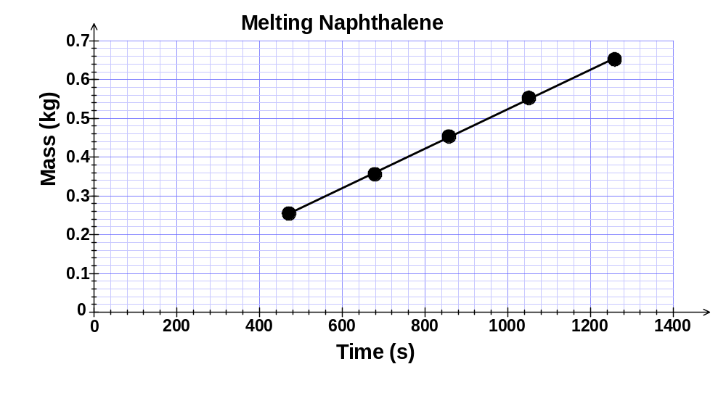

(b) Gradient is 5.00 x 10⁻ ⁴ kg s⁻¹ (2 marks)

(c) Power = Q / t = m L / t
m / t is the gradient of the graph = 0.0005
Power = gradient x L
Power = 0.0005 x 1.48 x 10⁵ = 74
The power of the immersion heater is 74.0 W (4 marks)

(d) The calculated power of the heater would probably be less than its true rating. This is because there are some losses of heat to the surroundings as the naphthalene is heated. Some heat would be conducted to the containing vessel and this would not be included in the calculation. The time taken to melt the naphthalene in each case would be longer than if there were no heat losses. (2 marks)

Question 21 (12 marks)
(a)
Table of results

Measurement | Data
Mass of copper calorimeter | 73.0 g
Mass of calorimeter + warm water | 159 g
Mass of calorimeter + warm water + ice | 193 g
Mass of warm water | 86 g
Mass of ice | 34 g
Initial temperature calorimeter + warm water | 41.6 °C
Final temperature calorimeter + warm water + melted ice | 9.00 °C
Temperature change calorimeter + warm water | 32.6 ºC
Initial temperature of ice | 0.00 °C
Temperature change of melted ice (water) in calorimeter | 9.00 ºC
(4 marks)
(b)
Heat gained by ice = Heat lost by calorimeter and warm water
m c ΔT + m L = m c ΔT + m c ΔT
(0.034 x 4180 x 9) + (0.034 x L) = (0.086 x 4180 x 32.6) + (0.073 x 380 x 32.6)
1279.08 + (0.034 x L) = 11 719.048 + 904.324
1279.08 + (0.034 x L 12 623.372
0.034 L = 12 623.372 - 1279.08
L = (12 623.372 - 1279.08) / 0.034
L = 3.34 x 10⁵ J kg⁻¹ (8 marks)

Question 22 (8 marks)

(a) Ohms law is V = I R. When an ohmic conductor (resistor) is placed in an electrical circuit and the potential drop across it is measured, the corresponding current through the resistor varies linearly.
A non-ohmic conductor (resistor) does not obey ohms law in as much as the measured potential across the resistor and the corresponding current are not linearly related.
(2marks)
(b) (i) P = V x I
I = P / V = 5 / 1 = 5.0 A
and
I = P /V = 5 / 100 = 0.05 A
The range of current is from 0.05 A to 5.0 A (2 marks)

(ii) Maximum power rating is 5.0 W. Therefore the maximum energy is 5.00 in
1 second. (2 marks)

(iii) As the resistor has a constant resistance the factors that determine the power
dissipated are the current flowing and the potential applied across the resistor. (2 marks)

Section 3: Comprehension (16 marks)

Question 23

(a) In contrast to petrol driven vehicles, e-bikes produce no undesirable emissions such as methane and carbon dioxide so do not contribute directly to polluting the atmosphere. However because the battery is charged from the mains it could be argued that in the production of the mains electricity, greenhouse gases were produced. (2 marks)

(b) Cycling is a form of exercise that can be undertaken by a wide range of people. Good diet and exercise are recognised as essential things you need to have to promote good health. Cycling increases aerobic performance as well as providing low impact forces on legs and arms.
E-bikes allow older people and people with less strength to participate in an activity that
they would otherwise be unable to do. (2 marks)

(c) P = V I
200 = 36 x I
I = 200 / 36
I = 5.56 A (2 marks)

(d) The 10 Ah battery can deliver the equivalent of 10 A for 1 hour
If the battery is delivering 3A then it will deliver power for 10 / 3 = 3.3 hours.
(2 marks)

(e) When engaging the pedal assist function the power output of the motor would decrease. This would conserve power so the distance the rider could travel using the motor would increase. (1 mark)

(f) The current would decrease so the time the rider could use the motor to propel the
e-bike would increase. (1 mark)

(g) I = q / t
2.0 = q / (2 x 60 x 60)
q = 2 x 2 x 60 x 60
Quantity of charge = 1.4 x 10⁴ C (2 marks)

(h) P = V² / R
200 = 36² / R
R = 36² / 200
R = 1296 / 200 = 6.5 Ω (2 marks)

(i) W = V I t = 36 x 3 x (3 x 60 x 60) = 1.2 x 10⁶ J (2 marks)

